**Microsoft Teams End User Guide**

This document is a guide for the more common functions that users would need instructions for in Microsoft teams.

**Table of Contents**

1. Creating a Team
2. Creating a Channel
3. Conversations
4. Files
5. Wiki
6. Adding more Tabs
7. **Creating a team**

To create a new team, which you might need to do when you start a new project, or need to coordinate something else.

In the left navigator menu and select “Create team.”on the bottom,

1. Select how you’re creating a team
2. Creating a team from Scratch which means you’ll have to add your teammates into the group.
3. Create from Office 365 Group - There is an existing group that you want to create a team from and it will auto-populate the team.
4. Select what kind of team this will be
5. Private - People need permission to join
6. Public - Anyone in your Org can join
7. Org-wide - everyone in your organization automatically joins
8. Give your team a name and a friendly description

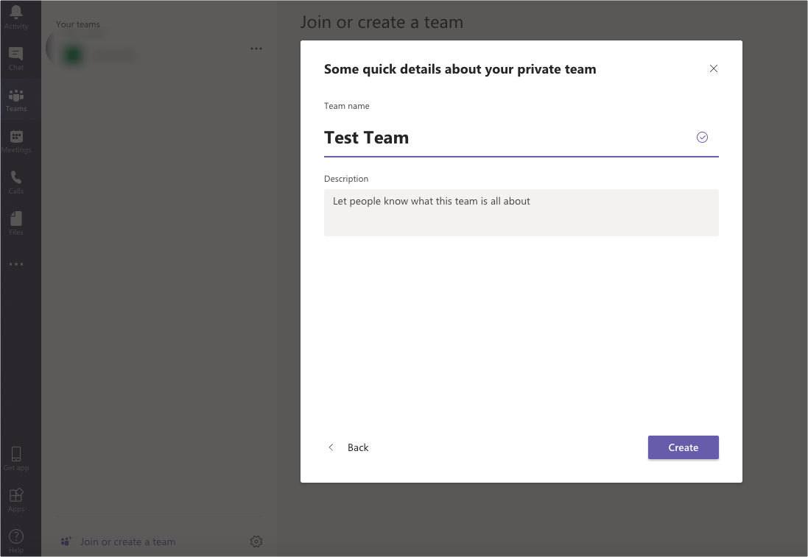

**2. Creating a Channel**

After you created the team you’ll notice some new things in the teams Windows. You’ll notice that a General channel has been created for the team. A channel is where you have conversations and collaborate. This channel is meant for a more general discussion when you begin the project. You can create additional channels for more specific topics of discussion. You can create multiple channels for any given team. Each channel will have a separate tab. When someone does something new, the channel will turn bold. They use this as chat notifications.

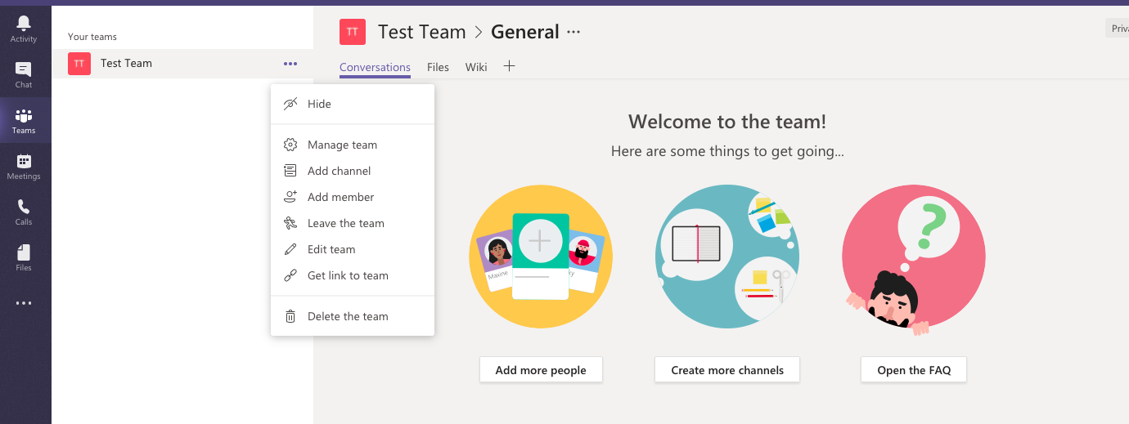

**3 Conversations**

The Conversations tab kind of works like Facebook or social media in that you can comment to your teammates or call their attention to something with the symbol.

**4. Files**

You can upload, open, edit, copy, move, download and delete files, link them from sharepoint or get links to those documents to share with others.

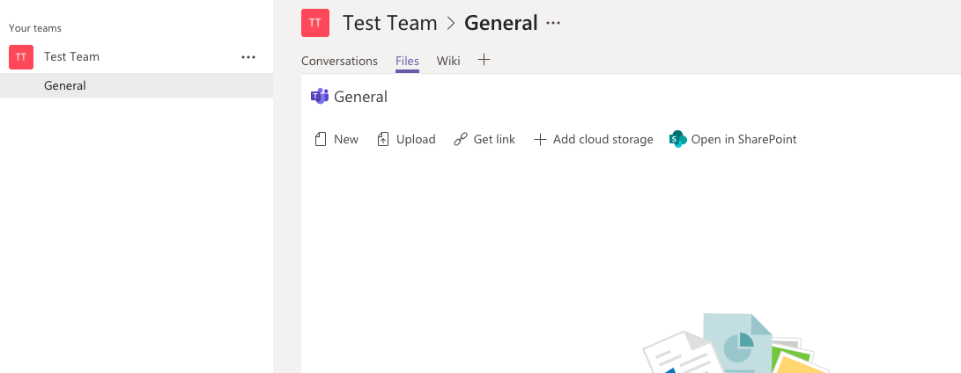

**5. Wiki**

Wiki is where you can put general how to’s and knowledgebase.



**6. Adding more tabs.**

You can add more tabs that link to a variety of functions and apps by clicking the “+” symbol

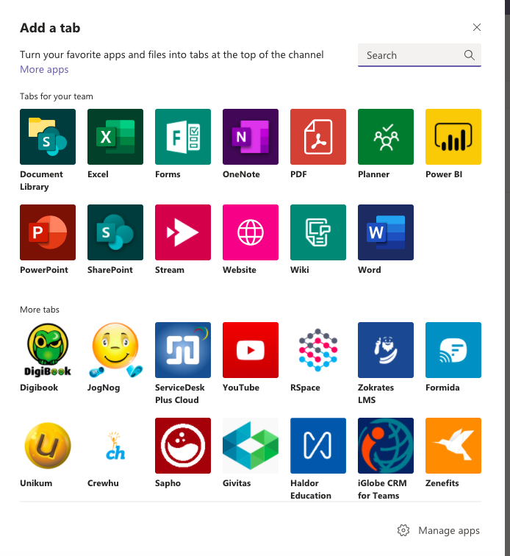

**7. Navigation Bar**

On the left side of Teams you will see a navigation panel with icons. This will lead you to other functions.

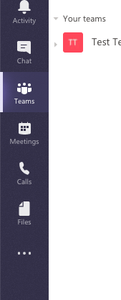

1. Activity - you can see the logs or feeds of all the updates and it provides a search function
2. Chat - lists all yoru chats
3. Teams - shows all your teams
4. Meetings - shows all your Microsoft Teams meetings
5. Calls - Call history
6. File - lists your recently viewed files